FROST BRIDGE CAMP MEETING

**Daily Meetings at 10:30 A.M. and 7:00 P.M.**

**JULY 18-27, 2025**

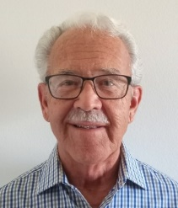 **Evangelists Missionary Youth Minister Youth Coordinator**

**Dr. Matt Rev. Paul Rev. Steven Rev. Duke Macy Garner**

**Friedeman Womack Hughes Underwood**

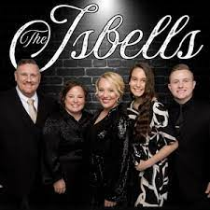***Sharing God’s Word in morning and night services***

**Morning Bible Study Music Ministry**

**led by Dr. Matt Friedeman the Isbells**

**and**

**Moneica Fowler**

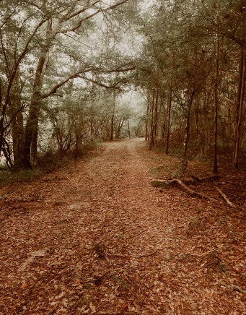 **Children’s Ministry**

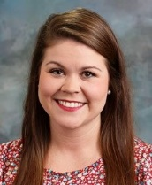**Dallas Carpenter and Josi Gaston SPECIALS 7:00 PM**

 **Isbell Family – Musical Evangelists**

**PROCLAIMING THE WESLEYAN**

**DOCTRINE OF SCRIPTURAL HOLINESS**

**RATES FOR 10 DAYS “…ask for the old paths,**

**0-3 years, No charge – 4-6 years, $60 – 7-11 years, $100 – 12-18 years, $200 where is the good way…”**

**Standard rooms --$25 per night— Family rooms $35 per night Jeremiah 6:16**

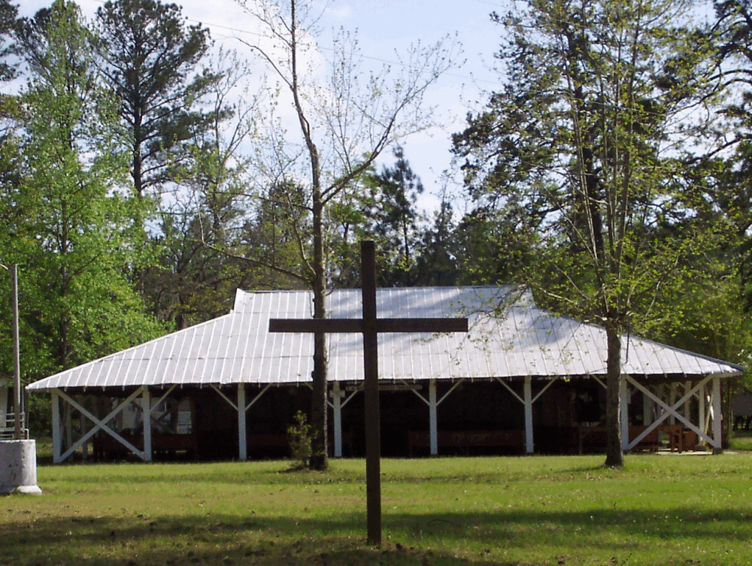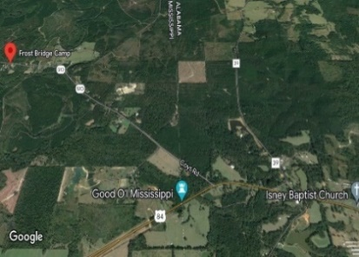 **RV campsites --$25 per day**

**Breakfast $5.00, Lunch $8.00, Supper $6.00**

**For information and registration please contact our**

**registrar:**

**Moneica Fowler**

**301 E. Broadway**

**Summerdale, AL 36580**

**251 269 3366**

**GPS: 1455 Matherville Frost Bridge Rd.**

**Waynesboro, MS 39367**

**For more information contact Richard Roach at 601 323 5780**

**I**